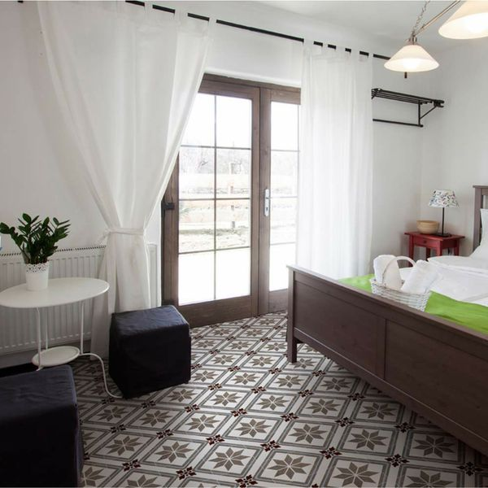**Memoir Encaustic Penzance Pattern Tiles:**

## **Product Description**

Create a charming period look in your home with our Penzance Scored Tiles. They have an ornate vintage pattern, and are perfect for creating a statement floor in a bathroom, kitchen or living area. You can even use them to create a striking first impression on guests, by introducing them into the hallway. They are made from ceramic and have a matt finish. They belong to our collection of Memoir Encaustic Effect Tiles and are named after a charming Cornish fishing town, strife with charming Victorian homes. This tile has a scored design, which you grout; each tile then gives the illusion of four separate tiles.

## **Product Info**

* Product ID: 15384
* Tiles Per SQM: 4.9382716049383
* Sale by: Per SQM
* Size: 450x450x10mm
* Weight: 4.06 KG
* Material Type: Ceramic
* Finish: Matt
* Colour: Multicolour
* Suitability: Floors
* Grade: 4
* Rectified Edge: No
* Underfloor Heating: Yes
* Thickness (mm): 10